Supporting Information
Table S1 Partitioning of the standardized total effects of vegetation loss on the Shannon-Wiener index (alpha diversity) and community composition (beta diversity) of rare, abundant, and all phylotypes of soil bacteria and fungi via abiotic and biotic variables for each N-enrichment level. ANPP, above‐ground net primary productivity; PCS, plant community structure; SOC, soil organic carbon; TSN, total soil nitrogen; ION, soil inorganic N.
N Level | Variable | Shannon-Wiener index |  |  |  |  |  | PCoA1
N Level | Variable | Bacteria |  |  | Fungi |  |  | Bacteria |  |  | Fungi
N Level | Variable | All | Abundant | Rare | All | Abundant | Rare | All | Abundant | Rare | All | Abundant | Rare
N0.00 | ANPP | 0.90 | - | -0.50 | - | - | - | - | 0.95 | - | - | - | 0.68
N0.00 | PCS | - | - | - | -0.38 | -0.32 | - | - | - | - | - | - | -
N0.00 | SOC | - | 0.48 | 0.32 | - | - | -0.35 | -0.31 | -0.35 | -0.31 | -0.33 | -0.49 | -
N0.00 | TSN | -0.22 | - | -0.41 | - | - | -0.20 | - | - | - | - | 0.24 | -
N0.00 | pH | - | 0.26 | - | - | - | - | -0.11 | - | -0.21 | - | - | -0.34
N0.00 | ION | -0.93 | -0.92 | - | - | - | - | - | -0.94 | - | - | - | -
N0.00 | r² | 0.54 | 0.45 | 0.66 | 0.16 | 0.11 | 0.47 | 0.42 | 0.43 | 0.42 | 0.20 | 0.36 | 0.29
N5.25 | ANPP | -0.58 | - | - | - | - | -0.58 | - | - | - | - | - | 0.45
N5.25 | PCS | - | - | 0.01 | - | - | - | - | 0.01 | - | - | - | -
N5.25 | SOC | 0.30 | 0.31 | - | - | - | 0.17 | -0.43 | -0.22 | - | -0.41 | -0.12 | -0.17
N5.25 | TSN | - | -0.32 | - | - | - | - | - | - | - | - | - | -
N5.25 | pH | - | 0.24 | - | - | - | - | - | -0.29 | -0.16 | - | - | -
N5.25 | ION | 0.17 | - | 0.15 | -0.18 | - | -0.18 | -0.17 | - | -0.23 | -0.22 | -0.18 | -0.21
N5.25 | r² | 0.47 | 0.45 | 0.20 | 0.22 | 0.00 | 0.60 | 0.63 | 0.60 | 0.59 | 0.45 | 0.32 | 0.34
N17.50 | ANPP | - | - | - | - | - | - | - | - | - | 0.98 | 0.84 | -
N17.50 | PCS | -0.67 | - | -0.78 | 0.55 | 0.63 | -0.55 | 0.54 | - | 0.55 | - | - | 0.57
N17.50 | SOC | - | - | - | - | - | - | -0.13 | - | -0.15 | -0.23 | -0.23 | -
N17.50 | TSN | 0.20 | - | 0.30 | - | - | - | - | - | - | - | - | 0.21
N17.50 | pH | 0.57 | 0.46 | 0.52 | -0.32 | -0.53 | 0.56 | -0.67 | -0.50 | -0.70 | -0.67 | -0.60 | -0.65
N17.50 | ION | - | -0.20 | - | - | - | - | - | 0.19 | 0.11 | - | - | 0.17
N17.50 | r² | 0.55 | 0.40 | 0.60 | 0.28 | 0.45 | 0.44 | 0.66 | 0.46 | 0.72 | 0.55 | 0.47 | 0.69
Figure S1 Responses of the richness (alpha diversity) of bacteria (a, all phylotypes; b, abundant phylotypes; c, rare phylotypes) and fungi (d, all phylotypes; e, abundant phylotypes; f, rare phylotypes) to vegetation loss (+Plant, with plants; -Plant, without plants) at different N-enrichment levels. Values are the means (±SE) of 10 replicate subplots. Statistical comparisons are described in Figure 2.
Figure S2 Relationships between the alpha diversity of all bacterial phylotypes and abundant or rare bacterial phylotypes (a-b) and between the alpha diversity of all fungal phylotypes and abundant or rare fungal phylotypes (c-d). Regression statistics are indicated (r and P).
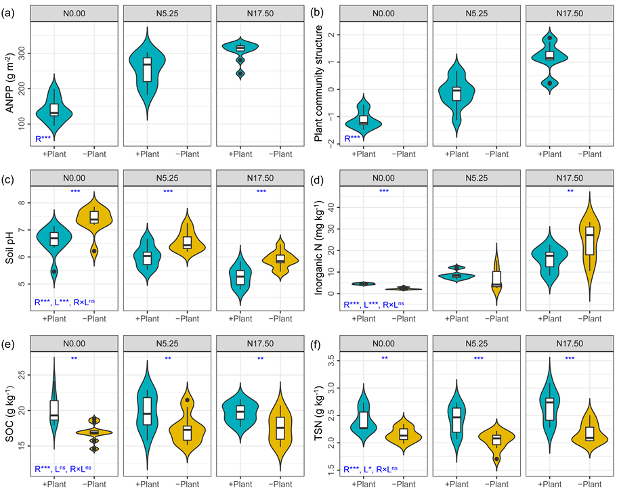
Figure S3 Responses of plant and soil variables to vegetation loss (+Plant, with plants; -Plant, without plants) at different N-enrichment levels. ANPP, above‐ground net primary productivity; SOC, soil organic carbon; TSN, total soil nitrogen. Values are the means (±SE) of 10 replicate subplots. Statistical comparisons are described in Figure 3.

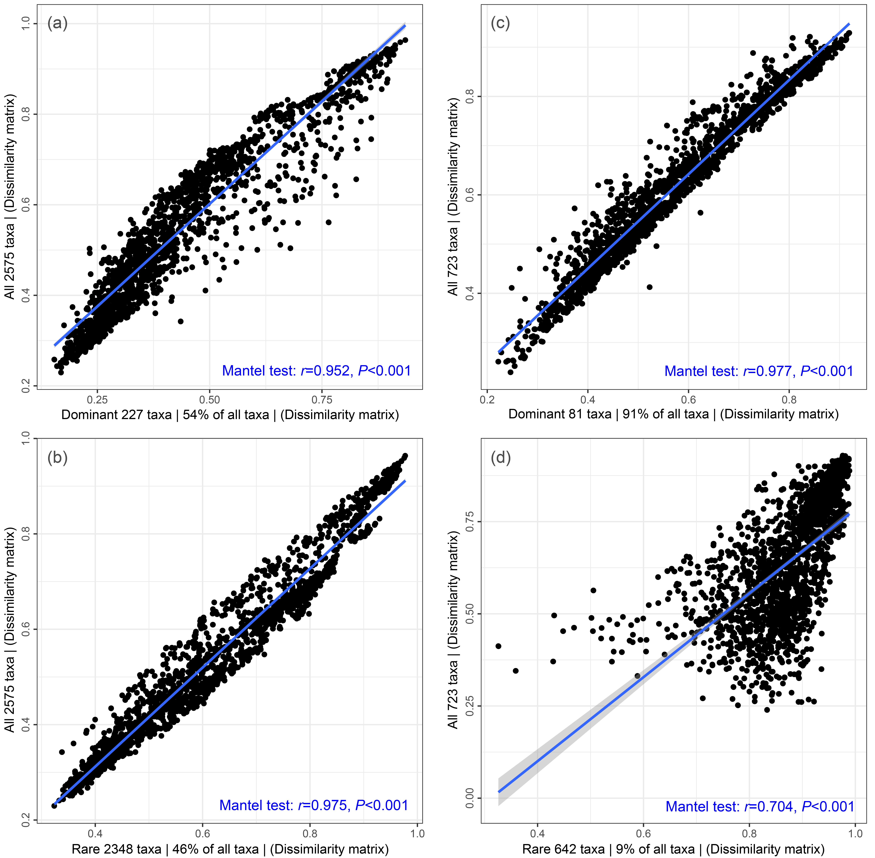
Figure S4 Relationships between the community composition (beta diversity) of all bacterial phylotypes and abundant or rare bacterial phylotypes (a-b) and between the alpha diversity of all fungal phylotypes and abundant or rare fungal phylotypes (c-d). Each point represents the community composition similarity based on Bray-Curtis similarity distance. Regressions were estimated using a Mantel test, and regression statistics are indicated (r and P).

